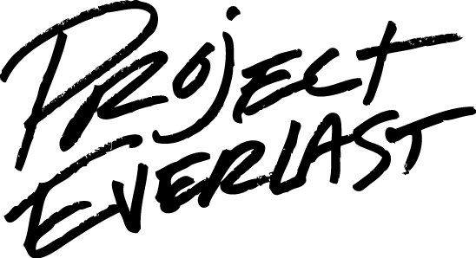
Membership Recruitment Checklist
Utilize this checklist to explore current efforts and potential opportunities for increasing your membership through effective marketing.

Does your council have…?
- Flyers for upcoming events and council details (purpose and ways to be involved) placed on bulletin boards of partner organizations or other areas where youth in/of care may be?
- Brochures/one-sheeters created to be left at public and non-profit agencies to inform the public current projects and recent updated?
- Business cards to be distributed to those commonly in contact with your agency or any youth you come across in your line of work?
- Information posted on organizational websites about your council, how to be involved and access to a sign-up form?
- Brainstormed with current members about locations, professionals, programs, etc. where potential members could be found?
- Developed an awareness of your efforts among agencies serving your population?
- A scrapbook of consumer group’s activities?
- Planned and hosted social, recruitment events where potential members can mingle with current members?
- Relationships with key community champions, agencies and programs?
- A listserv of child city, service area or state administrators and other organizations involved in serving your consumer population?
- Members who are aware of the sign-up procedure and engaged in reaching out to peers and professionals in their lives?
- The option for potential members to visit a meeting/event as a guest or somehow “check-out” the council before deciding to join?
- Specific dates scheduled for your meetings?
- Active use of social media, including the council Facebook page, to promote local events and successes?
- Clear short-term and long-term local goals for new members to get excited about? If so, are current members able to share these?
- Current members actively engaged in recruiting new members?

What are your goals for membership?
______________________________________________________________________________________________________________________________________________________________________________________________________________________________________________________________________________________________________________________________________________________________________________________________________

How are you currently going about achieving them?
____________________________________________________________________________________________________________________________________________________________________________________________________________________________________________________________________________________________________________________________________________________________________________________________________________________________________________________________________________________

What additional steps are you planning to try in the next three months?
______________________________________________________________________________________________________________________________________________________________________________________________________________________________________________________________________________________________________________________________________________________________________________________________________

Who and/or what support do you need to make these goals a reality?
______________________________________________________________________________________________________________________________________________________________________________________________________________________________________________________________________________________________________________________________________________________________________________________________________

What steps will you take to include members in your marketing/recruitment plans?
______________________________________________________________________________________________________________________________________________________________________________________________________________________________________________________________________________________________________________________________________________________________________________________________________

How will you know these goals have been achieved?
______________________________________________________________________________________________________________________________________________________________________________________________________________________________________________________________________________________________________________________________________________________________________________________________________

