The purpose is to improve and enhance child well-being in Nebraska by promoting and aligning actions with measurable key outcomes over time, at the state, regional, and community level.

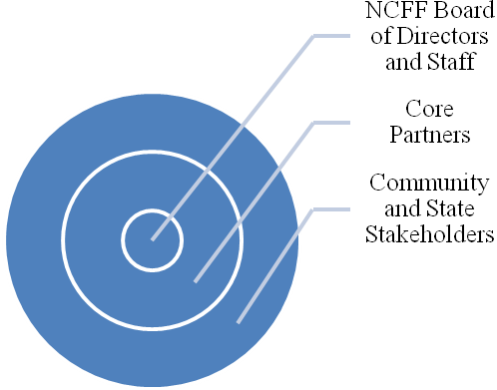
History and Development
- Beginning in 2007, various state public and private agencies came together to develop a vision to achieve the best outcomes for children and youth along the lifespan (ages 0-24)
- Work was initiated by champions of children and youth on the Nebraska Children and Families Foundation (NCFF) Board of Directors
- Research was conducted into other state’s indicators, indicators currently measured in Nebraska, what data exists, and the quality of said data.
- From a list of 60 possible indicators, 14 Key Indicators were selected based on their communication, proxy, data, and action power.
- The 14 Key Indicators of Child Well-Being in Nebraska are being used to measure child well-being, align and identify gaps in services and programs in Nebraska, and improve the access to and overall quality of child well-being data in Nebraska
- In May of 2008, the first Call to Action Summit on High School Graduation Rates was held in Lincoln, NE. This summit featured graduation and dropout data in Nebraska, and focused on developing statewide strategies to improve graduation rates.
- In conjunction with America’s Promise, the second Call to Action summit will be held in May 2009. This summit will focus on dropout prevention strategies.

Membership
- Core Partners: Nebraska Children and Families Foundation, Nebraska University Foundation, Nebraska Department of Health and Human Services, University of Nebraska Medical Center, University of Nebraska-Lincoln (UNL), UNL Center for At-Risk Children, NU Public Policy Center, Buffett Early Childhood Fund, Boys Town, Nebraska Department of Education, Nebraska Crime Commission, Voices for Children
- Community and other state stakeholders

Advisory and Workgroups
- Core Partners: input ideas, review and make decisions on data, evidence-based research and other background information, final decision makers on input from stakeholders and workgroups, attend quarterly meetings
- Community and State Stakeholders: input ideas and make recommendations, review and comment on data, evidence-based research and other background information, implement actions, measure outcomes, and reflect on progress
- Data Subcommittee: find and review data on 14 Key Indicators, determine strength and quality of data, make recommendations to core partners and stakeholders on how best to use and strengthen the data
- High School Graduation Rates Subcommittee: implement the Statewide Strategies that were developed at the 2008 Call to Action Summit on High School Graduation.
- Early Childhood Subcommittee: work with Core Partners, the Early Childhood Policy Workgroup, and the Buffet Early Childhood Fund to develop early childhood-related indicators for use in shaping early childhood programs and policies in Nebraska

Administrative Home
- Nebraska Children and Families Foundation

Staffing
- Project Leader who is responsible for general direction and oversight of the project
- Project Staff who is responsible for locating and organizing pertinent background information and data
- Chair of Core Partners
- Co-Chairs of Individual Subcommittees

Results Framework
- Utilize a comprehensive set of outcomes that can be used as a framework to enhance programs, services, and policies that improve the well-being of Nebraska’s children. These outcomes are:
  - Children are Healthy
  - Children are Safe
  - Children are Ready and Successful in School and Beyond
  - Children are Supported in Quality Environments
- Develop a set of indicators that align with the child well-being outcomes, which will be used to measure progress towards these outcomes

Initiatives
- Working to develop a data warehouse into which all child-serving agencies can contribute and access aggregate-level information across departments for better policy and decision-making.

Desired Results
- Have a common vision for child well-being across agencies
- Identify and ameliorate inefficiencies, gaps and duplication in services associated with key indicators
- Take a collaborative approach to improving a key set of indicators
- Work to uniformly to collect data for priority indicators
- Use data to develop new programs and policies and improve allocation and use of resources to maximize intended outcomes
- Reach consensus on collaborative actions, practices and policies for the prevention of the defined problems or other interventions

