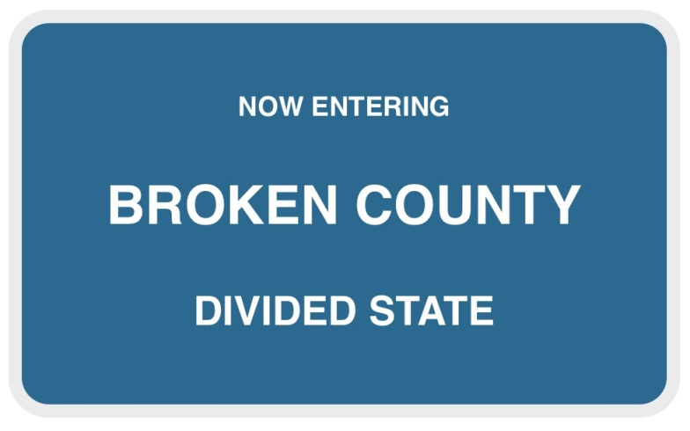
VISION STATEMENT:
“We are a committed community, working
together producing safe and healthy environments for children.”

“How can we, in the next 5 years, ensure the system‐wide use of effective policies and practices to support positive parent child interaction and impact child well-being?”

“What do we want to see in place 5 years from now as a result of our collective action?”

• A diverse and committed coalition
• Collective production of positive and healthy norms in children and families
• Resources that support individual and family needs
• Shared evaluation
• Communicating with intention

These elements would result from a continuum of strategies that focus on prevention and would result in sustainability.

The Mission of Broken County Partnership for Child Well-Being
We will build protective factors in families through a community based collaborative system of prevention services.
Specifically, we will provide:
- Safe and healthy environments where children and families are valued and engaged.
- Programs and strategies focused on Prevention/Early Intervention
- Opportunities for community teamwork and resources to provide holistic services
- Strong leadership committed to the process and demonstrated through policies, Open and sustainable communication and Ongoing Assessment
GOALS AND WORKGROUPS -- We will:
- INCREASE QUALITY EARLY EDUCATION OPPORTUNITIES/CHILD CARE CENTERS:
  - Capacity – affordable slots
  - Support and train existing child care providers to improve quality
  - Daycares and pre-schools indicated needs were:
    - How to build healthy family structures.
    - They need family enrichment skills and behavior skills training.
    - Would welcome a uniform curriculum.
- INCREASE SOCIAL EMOTIONAL WELLBEING OF YOUNG CHILDREN AND THEIR PARENTS
  - Development of /Referrals to PCIT, Save the Children, PIWI, Kid Squad
  - Increase family access to existing resources
  - Outreach to isolated families
- PREVENT CHILDREN FROM ENTRYING THE CHILD WELFARE SYSTEM
  - Pilot Community Based Services with Non-Court Involved Cases or Helpline Cases
  - DHHS staff connection to prevention – EC resources
    - Based on Service Array figure out what services need to be purchased
    - Resource person in the collaboration that DHHS can connect to for community based services
  - Families entering system:
    - Engage lower risk families
    - Understand their family strengths and needs
- STRENGTHEN COLLABORATIVE INFRASTRUCTURE TO PROVIDE COMMUNITY BASED PREVENTION SERVICES.
  - See attached work plan

